Measure of shape:
In descriptive statistics, The measure of shape refers to the characteristics of a data distribution, specifically how the data points are arranged around the mean. It helps in understanding the symmetry, peaked-ness, and spread of a dataset.

(Or)

In descriptive statistics, the measure of shape tells us how a dataset is distributed—whether it is symmetrical or skewed and how its tails behave
- Symmetry means the data is evenly spread around the central point, and the left side is a mirror image of the right side.

- Tail of a distribution refers to the ends (extreme left and right parts) of a dataset when plotted on a graph.

The two most commonly used measures of shape are:
- Skewness (Symmetry of the Distribution)
- Kurtosis (Peaked-ness of the Distribution)

1. Skewness (Measure of A symmetry)
Skewness describes how much a dataset deviates from a perfectly symmetrical distribution.
It measures whether, the data is skewed to the left (negative skew), right (positive skew), or symmetrical (zero skew).
In simple terms, skewness tells you if a data set leans to one side or the other. Here's a breakdown:
- Imagine a hill:
  - If the hill is perfectly symmetrical, it has zero skewness.
  - If the hill has a long tail stretching to the right, it's positively skewed (or right-skewed).
  - If the hill has a long tail stretching to the left, it's negatively skewed (or left-skewed).
- More specifically:
  - Skewness measures the lack of symmetry in a data distribution.
  - It helps us understand if the data is evenly distributed around its average, or if it's more concentrated on one side.

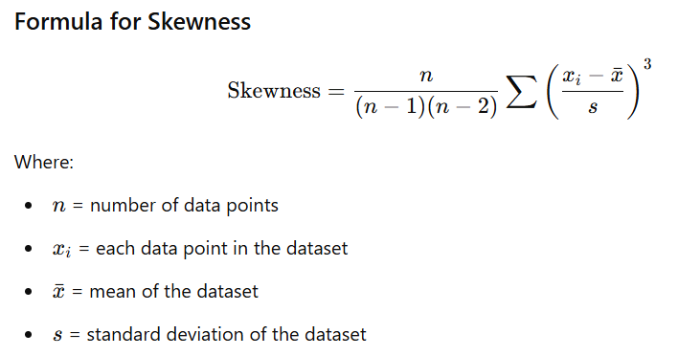
Types of Skewness:
There are three main types of skewness:
- A) Negative Skew (Left Skew):
  - The tail of the distribution extends more to the left.
  - The majority of the data is concentrated on the right.
  - The mean is typically less than the median.
  - Mean < Median < Mode
  - Example: Test scores where most students perform very well, with only a few low scores.
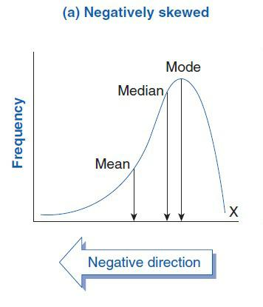
Image representation:
- B) Zero Skew (Symmetrical):
  - The distribution is perfectly symmetrical.
  - The left and right sides are mirror images of each other.
  - The mean, median, and mode are all equal.
  - Mean = Median = Mode
  - Example: A perfectly normal distribution.
most earn lower incomes).
- Image representation:
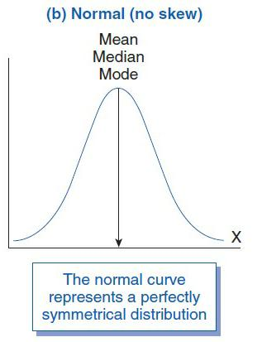

- C) Positive Skew (Right Skew):
  - The tail of the distribution extends more to the right.
  - The majority of the data is concentrated on the left.
  - The mean is typically greater than the median.
  - Mean > Median > Mode
  - Example: Income distribution (a few people earn very high incomes, while most earn lower incomes).

- Image representation:
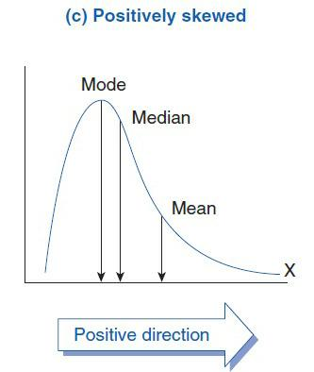

Lets solve an example upon skewness and form the contradiction on the data weather the data is positive, negative or zero skewed.

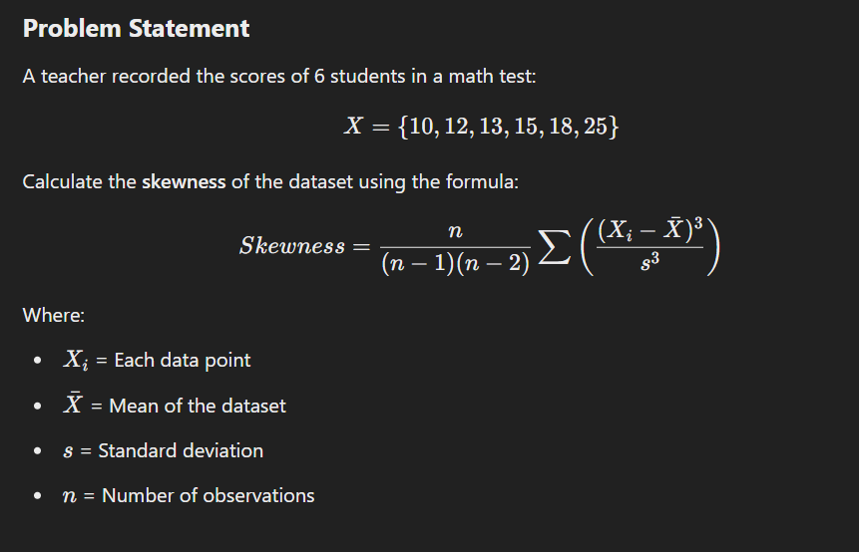
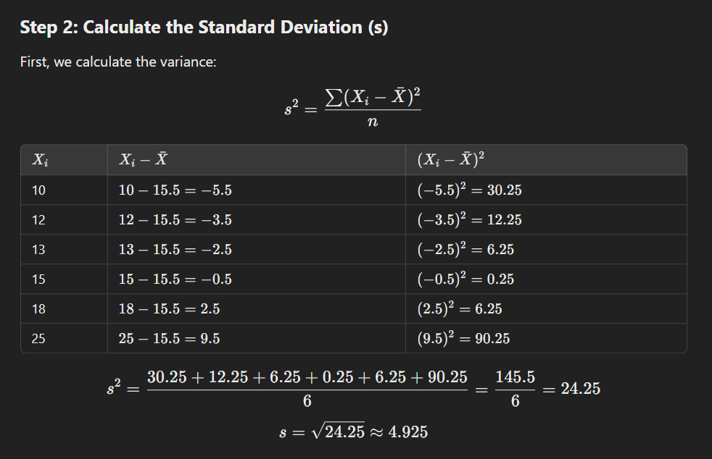
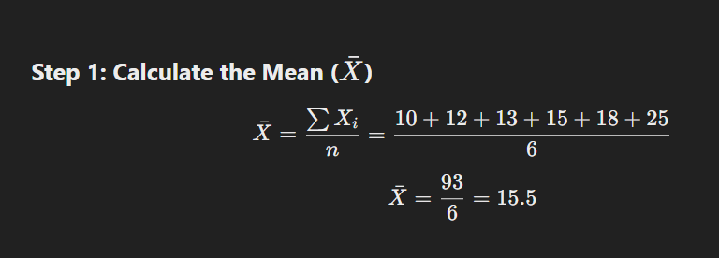


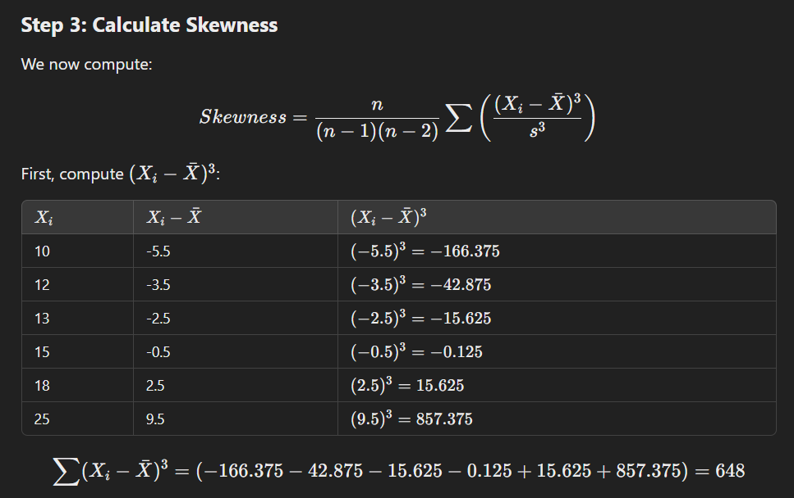
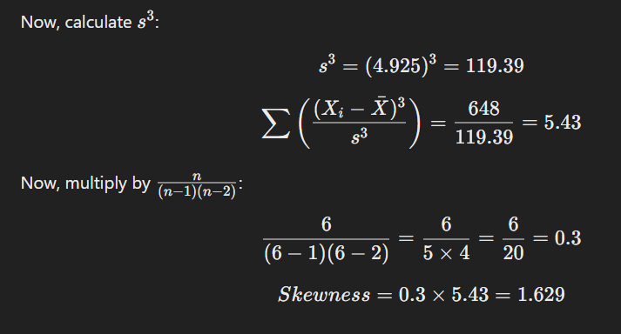
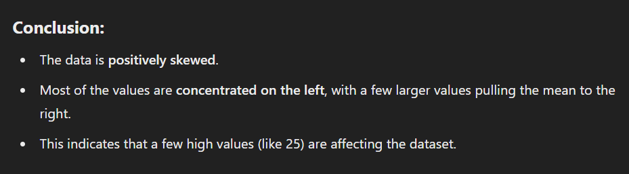

Problems to solve:
1)Data= 5,7,9,10,11,12,14
Solution: Negative skew
2)Data= 5,10,15,20,25,30
Solution: Zero skew

Karl Pearson’s Coefficient of Skewness :
Karl Pearson introduced two methods to measure skewness:
- Karl Pearson’s First Coefficient of Skewness (Mode-based)
- Karl Pearson’s Second Coefficient of Skewness (Median-based)
Both methods provide a simple way to determine whether a dataset is symmetrical, positively skewed, or negatively skewed.

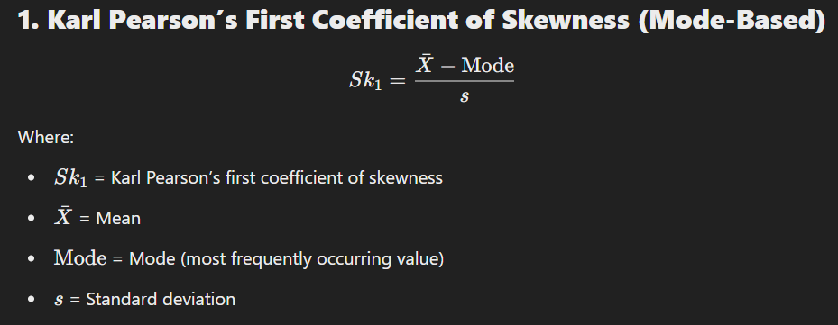
1.Karl Peasons’s First Coefficient of Skewness(MODE BASED).

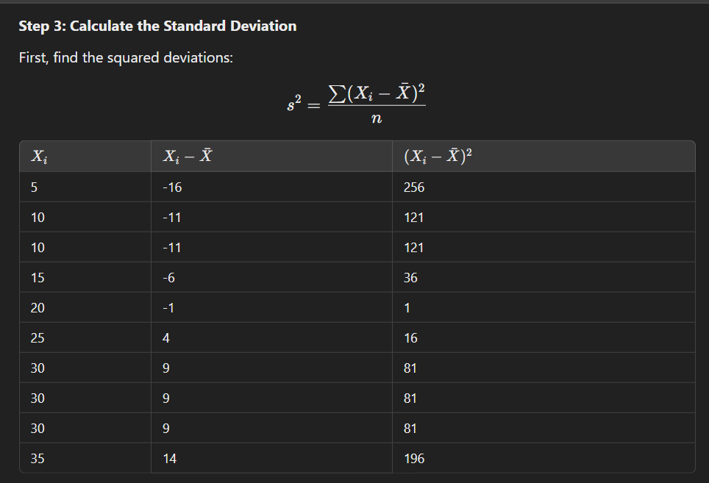
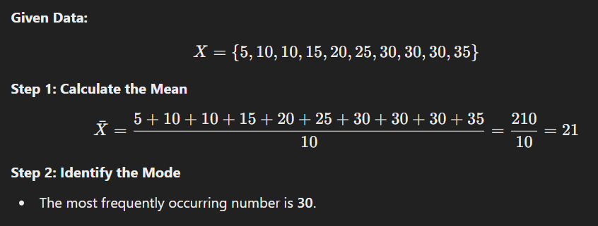
EXAMPLE CALCULATION:

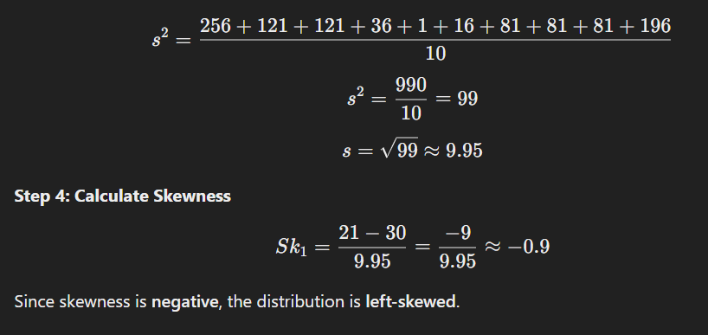

Note:
- In any case if the median and mean is equal, then in that same case there are max chances to that the mode will also equals to mean and median.
- But in all cases it will not obey so karl person introduced a formula to find mode that is:
If mean and median is available to find the mode:
Mode ≈ 3(Median) - 2(Mean)

Problems to solve:
Data= 3,5,7,8,10,12,25
Solution: Positive skew.
Data= 5,10,15,20,25,30
Solution: zero skew.

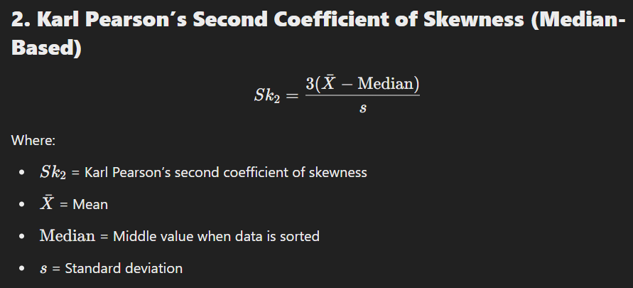
Karl Pearson’s Second Coefficient of Skewness (Median-Based).

EXAMPLE CALCULATION:
Data=[4,6,8,10,12]
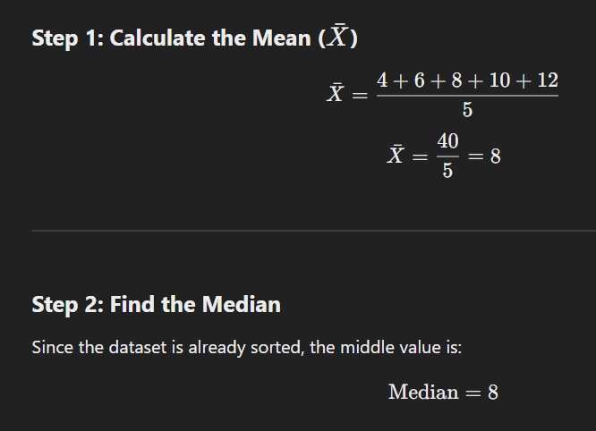
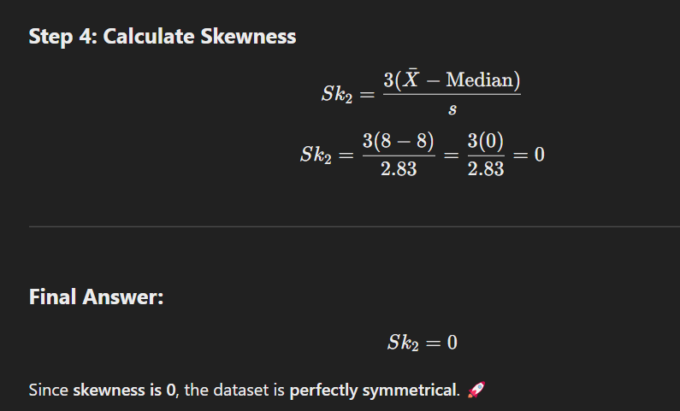
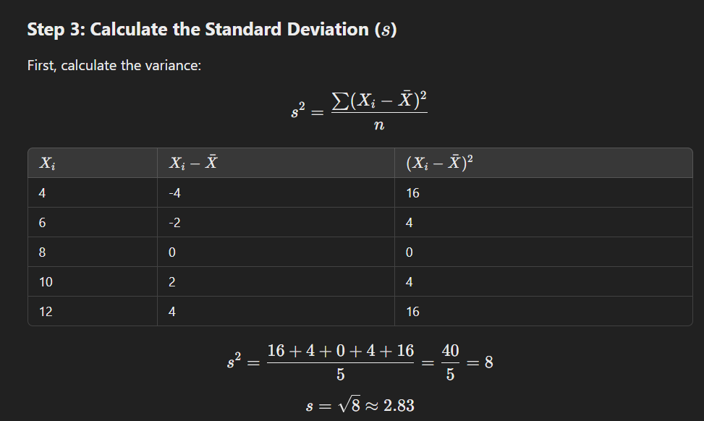

Problems to solve:
Data= 3,5,7,8,10,12,25
Solution: Positive skew.
Data= 80,85,90,95,100,110,120
Solution: Negative skew.

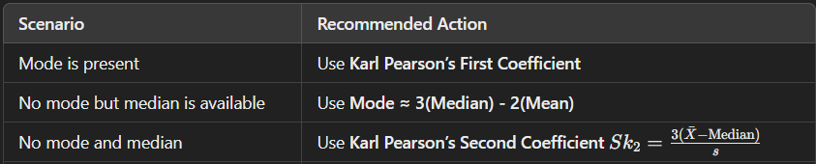
Which Method to Use?

2.Kurtosis (Peakedness Of The Distribution)

What is Kurtosis?
Kurtosis is a statistical measure that describes the tailedness or peak of a probability distribution compared to a normal distribution. It tells us how much of the variance is due to extreme values (outliers).
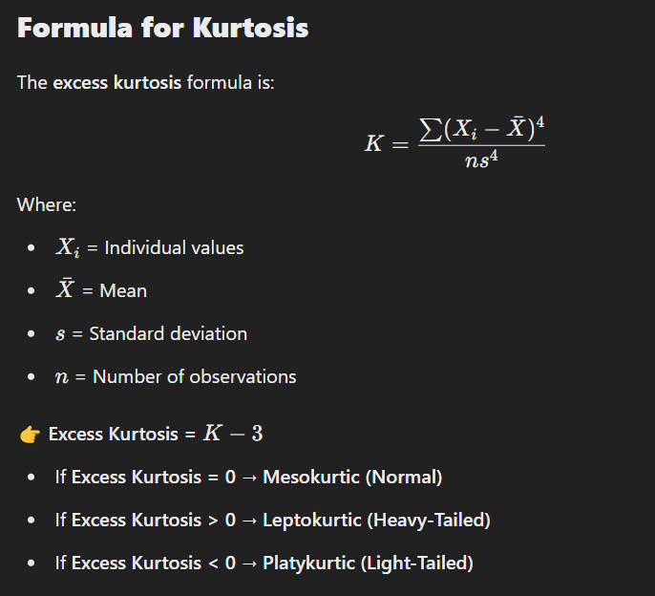

Types of kurtosis:

There are there types of kurtosis:

1. Mesokurtic (Normal Kurtosis)

- Kurtosis ≈ 0
- The distribution has a normal peak and tail.
- Example: Standard normal distribution (bell curve, IQ scores, human heights).
📉 Graphically: The peak and tails are similar to a normal distribution
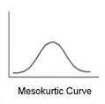

2. Leptokurtic (Heavy-Tailed, Sharp Peak)
- Kurtosis > 0
- The distribution has a higher peak and fatter tails (more extreme outliers).
- Example: Stock market crashes, earthquake magnitudes.
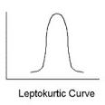
📈 Graphically: The peak is very high, and there are more extreme values in the tails.

3. Platykurtic (Light-Tailed, Flatter Peak)
- Kurtosis < 0
- The distribution has a flatter peak and thin tails (fewer extreme outliers).
- Example: Uniform distribution, rolling a fair die, evenly distributed test scores.
📊 Graphically: The peak is lower, and the tails are thinner.

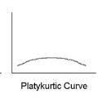

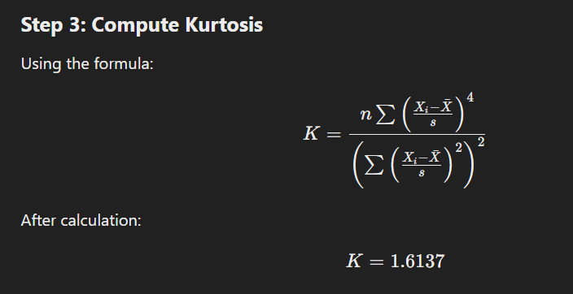
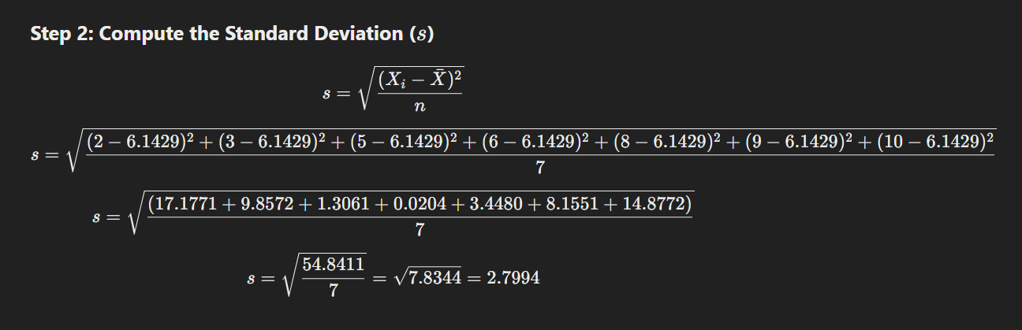
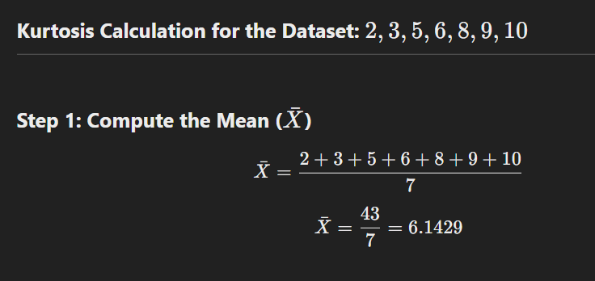
Calculating the kurtosis:

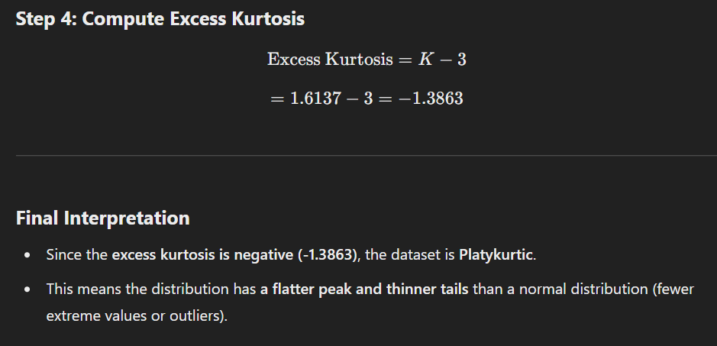
some questions to compute:
- Find the kurtosis for the dataset: 3,5,7,9,11,13,15.
- Calculate the kurtosis for 4,6,8,10,12,14,16,18.
- Given the values 1,2,2,3,3,4,4,5,5,6 determine the kurtosis and classify it as mesokurtic, leptokurtic, or platykurtic.
- A dataset has values 2, 3, 5, 7, 10, 15, 20. Calculate the kurtosis and determine whether the distribution is heavy-tailed or light-tailed.
- For the dataset 3, 3, 4, 5, 5, 6, 6, 7, 8, find the mean, standard deviation, and kurtosis.

